
Chapter 40B Affordable Property
Resale Application 2025

16 Village Way # 5 in Natick, MA 01760
Natick Village Condominium

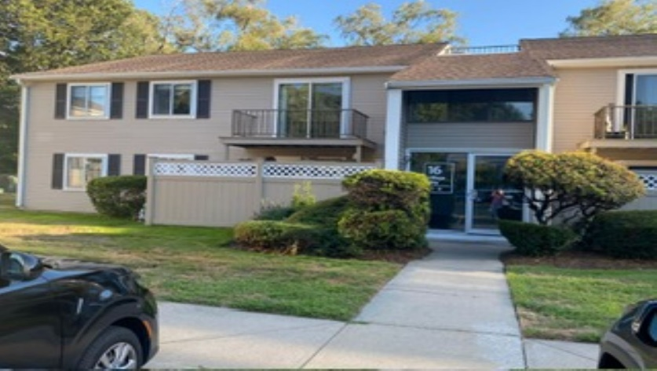

Offered at $246,177. First comes first served

Packet Includes:
Household Eligibility Form
Disclosure Form
Application Checklist

Applications will be reviewed on a first-come, first-served basis. Only complete applications will be reviewed and approved.

Household Eligibility Form

Eligibility Criteria

Max annual gross income:
- Household of: 1 person-$92,650; 2-105,850; 3 —$119,100; 4-$132,300
- Max liquid assets $75,000
- Household cannot have more than $75,000 in assets.
- Applicants must be first-time homebuyers (have not owned a home in last 3 years)

Applicant Information (Please Print)

Name:

Address:

City: State: Zip Code:

Telephone: Email:

Co-Applicant Information (if applicable)

Name:

Telephone: Email:

Household Information
Please list ALL household members, regardless of age, who will occupy the affordable home:

Name Date of Birth Relationship

First-Time Homebuyer
Have you owned a home or a joint interest in a home in the past three years from the date of this application? □ YES □ NO

If yes, please explain:

Real Estate Agent Contact Information (if applicable)*

Name: Agency:

Telephone: Email:

How did you hear about this property? ______________________________________________

Pre-Approval Information
Omega Ventures Inc., recommends working with a local bank or credit union for your mortgage financing. Also, please note that FHA does not approve loans for Chapter 40B properties.

Please provide a copy of your preapproval letter.

Lending Institution/Bank: Amount of Pre-Approval:

Date of Pre-Approval: Amount of Down Payment:

- If you are working with a real estate broker under a buyer’s contract, please make sure you disclose your application since this resale does not offer commission to buyer’s broker

Income Information
Please list sources of income for all household members. Income includes gross wages or salary, retirement account income withdrawals, self-employment income, veteran’s benefits, alimony/child support, unemployment compensation, Social Security and supplemental income, pension/disability income, and dividend income. Please note any recent significant changes in amounts received.

Please provide documentation of all income, including:
- Five most recent pay stubs
- Federal Tax Returns for the last three years
- W2s for the most recent year
- Social Security/benefit award letter
- Pension/retirement documentation including cash values
- Child support/alimony award or proof of receipt

Source of Income Household Member Amount per Year

If there are additional sources of income, please attach a separate page.

Employment Information

Household Member: Employer Name:

Position/Title: Date of Hire:

Household Member: Employer Name:

Position/Title: Date of Hire:

Household Member: Employer Name:

Position/Title: Date of Hire:
If there are additional employers, please attach a separate page.
Asset Information
Please list the asset information for all household members. Assets include liquid assets, such as checking or savings accounts, stocks, bonds, the cash-value of retirement accounts, cash gifts, and other forms of capital investments, excluding personal property, automobiles, government sponsored down payment assistance programs, equity accounts in homeownership programs or state assisted public housing escrow accounts.

Please provide documentation of all assets, including the most recent monthly statement for all accounts.

Household Member: Bank:

Account Type: Last 4 of Acct. #: Balance:

Household Member: Bank:

Account Type: Last 4 of Acct. #: Balance:

Household Member: Bank:

Account Type: Last 4 of Acct. #: Balance:

Household Member: Bank:

Account Type: Last 4 of Acct. #: Balance:

Household Member: Bank:

Account Type: Last 4 of Acct. #: Balance:
If there are additional assets to list, please attach a separate page.

Gifts
Will the household be receiving a cash gift from a friend or family member to help with the purchase of this property? □ YES □ NO

Name of Source: Relationship to Applicant:

Amount of Gift:

If receiving a gift, please include a letter signed by the donor stating that the amount and that the contribution is a gift.

Certification
I certify that all the information and documentation provided for this application is true and complete to the best of my knowledge. I further understand that:
- All information is subject to verification by EOHLC
- information may lead to disqualification from the application process.
- I will provide additional information as requested and failure to do so in a timely manner may lead to disqualification from the application process.

______________________________
Applicant Name

______________________________ _______________
Applicant Signature Date

______________________________
Co-Applicant Name

______________________________ _______________
Co-Applicant Signature Date

Disclosure Form

Please check and fill in the following items that apply to you.

- I/We certify that our household size is _______ persons.

- I/We certify that our annual household income is ________________. All sources of income from all household members has been included.

- I/We certify that my/our total liquid assets do not exceed the asset limit.

- The household size listed on the application form includes only and all the people who will be living in the residence. I/We intend to use the property as our primary residence as long as we own the property.

- I/We certify that the information contained in this application is true and accurate to the best of my/our knowledge and belief under full penalty of perjury. I/We understand that perjury will result in disqualification from further consideration.

- I/We further authorize EOHLC to verify all income, employment, asset, or other financial information. I/we authorize any employer, property owner or financial institution to release any information to CHAPA, as the project’s monitoring agency, for determining the eligibility of this household eligibility to purchase this property.

- I/We understand that it is my/our obligation to secure the necessary mortgage for the purchase of the home and that all expenses, including closing costs and down payments, are my/our responsibility.

- I/We understand that submitting this application does not guarantee that I/we will be able to purchase this property. I/We understand that the application will be reviewed in accordance with CHAPA’s Buyer Selection and Approval Policy. I/We have reviewed and understand that process.

- I/We have been provided and have reviewed the Chapter 40B affordable housing deed rider policies that will apply to this property should I/we purchase it. I/We agree to the restrictions including those regarding residency, resale, refinancing, and repair.

Applicant Signature Date

Co-Applicant Signature Date

Application Checklist & Submission Instructions
At the first step please send the application completely filled out and a pre-approval letter.
No other docs at this time. Application will be screened. If you seem qualified you will be assigned an application number. When your number will be called, we will arrange an own showing. After the showing and if you are interested to proceed all your documents will be reviewed. Your application is NOT considered COMPLETE without the following documents. Incomplete applications will not be eligible for first-come, first-served review.

Your application is NOT considered COMPLETE without the following documents. Incomplete applications will not be eligible for first-come, first-served review.

- Fully completed and signed Household Information Form
- All applicable income documentation, including:
  - Five most recent pay stubs,
  - Federal tax returns for the last three years
  - W2s from the most recent tax year 2024
  - Social Security or benefit award letter
  - Retirement or pension last month documentation including cash value
  - Child support/alimony award or proof of receipt
- All applicable asset documentation, including:
  - 2 full month recent checking and savings account bank statements. All deposits must be explained or itemized
  - Retirement/brokerage statements including cash value.
  - Gift award letter
- Pre-approval letter from a bank or mortgage company indicating your household qualifies for a mortgage sufficient to purchase the property
- Signed Disclosure Form

Submitting Your Application:
Please submit the complete application to (no docs at this point only application and pre approval)
Avi Glaser
aviglaser@comcast.net

After You Submit:
- Your application will be reviewed on a first-come, first-served basis. Only complete applications will be reviewed. Other complete applications received after an incomplete application is received will be reviewed first.
- If your application is not complete, every effort will be made to notify you of any additional information or documentation needed, but EOHLC cannot guarantee any review of applications to request additional documentation. PLEASE THOROUGHLY REVIEW YOUR APPLICATION BEFORE SUBMITTING.

