

Chapter 40B Affordable Property
Resale Application income and asset limits removed*

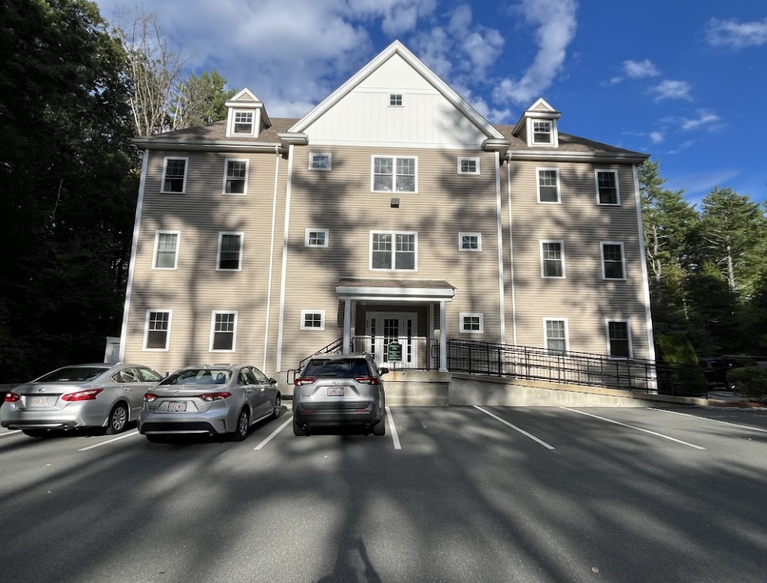
Development: Franklin Heights
Property Address: 24 Shayn Rd. 327 Franklin

Packet Includes:
Household Information Form
Disclosure Form

This application is for a purchaser that does not meet Chapter 40B income and asset guidelines but may purchase certain affordable properties because the deed rider allows sale to an ineligible purchaser after the affordable marketing period has ended. Property must be primary residence.

Applications will be reviewed on a first-come, first-served basis. Only complete applications will be reviewed and approved.

*Adopted from CHAPA

Household Information Form

Applicant Information

Name:

Address:

City: State: Zip Code:

Telephone: Email:

Co-Applicant Information (if applicable)

Name:

Telephone: Email:

Household Information
Please list ALL household members, regardless of age, who will occupy the affordable home:

Name Date of Birth Relationship

First-Time Homebuyer
Have you owned a home or a joint interest in a home in the past three years from the date of this application? □ YES □ NO

If yes, please explain:

Real Estate Agent Contact Information (if applicable)

Name: Agency:

Telephone: Email:

How did you hear about this property? ______________________________________________

Pre-Approval Information
CHAPA recommends working with a local bank or credit union for your mortgage financing.

Please provide a copy of your preapproval letter.

Lending Institution/Bank: Amount of Pre-Approval:

Date of Pre-Approval: Amount of Down Payment:

Certification
I certify that all the information and documentation provided for this application is true and complete to the best of my knowledge. I further understand that:
- All information is subject to verification by EOHLC/Omega Ventures Inc. and inaccurate information may lead to disqualification from the application process.
- I will provide additional information as requested and failure to do so in a timely manner may lead to disqualification from the application process.
- Applications will be reviewed in accordance with EOHLC. Buyer Selection and Approval Process.

______________________________
Applicant Name

______________________________ _______________
Applicant Signature Date

______________________________
Co-Applicant Name

______________________________ _______________
Co-Applicant Signature Date

Disclosure Form

Please check and fill in the following items that apply to you.

- I/We certify that our household size is _______ persons.

- The household size listed on the application form includes only and all the people who will be living in the residence. I/We intend to use the property as our primary residence as long as we own the property.

- I/We certify that the information contained in this application is true and accurate to the best of my/our knowledge and belief under full penalty of perjury. I/We understand that perjury will result in disqualification from further consideration.

- I/We understand that it is my/our obligation to secure the necessary mortgage for the purchase of the home and that all expenses, including closing costs and down payments, are my/our responsibility.

- I/We understand that submitting this application does not guarantee that I/we will be able to purchase this property. I/We understand that the application will be reviewed in accordance with CHAPA’s Buyer Selection and Approval Policy. I/We have reviewed and understand that process.

- I/We have been provided and have reviewed the Chapter 40B affordable housing deed rider and EOHLC policies that will apply to this property should I/we purchase it. I/We agree to the restrictions and to abide by all EOHLC policies, including those regarding residency, resale, refinancing, and repair. Policies available at www.chapa.org.

Applicant Signature Date

Co-Applicant Signature Date

